Message-Passing Systems
# Source: Chatgpt (GPT-5-Mini) at [1/16/2026]
A Message-Passing System is a type of distributed system in which processes (or nodes) communicate and coordinate by sending and receiving messages over a network instead of sharing memory.
It is one of the core communication methods in distributed systems, especially when nodes are physically separate.

Definition
# Source: Chatgpt (GPT-5-Mini) at [1/16/2026]
A Message-Passing System:
- Uses messages as the only means of communication between processes
- Each process has its own local memory
- Coordination, data sharing, and synchronization are done entirely through message exchange

Architecture Diagram
# Source: Chatgpt (GPT-5-Mini) at [1/16/2026]
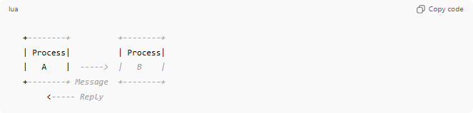
+--------+ +--------+
| Process| | Process|
| A | -----> | B |
+--------+ Message +--------+
<----- Reply
- Process A sends a request message to Process B
- Process B processes it and sends back a reply

Key Characteristics
# Source: Chatgpt (GPT-5-Mini) at [1/16/2026]
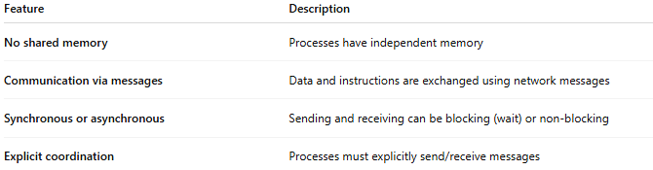
Feature | Description
No shared memory | Processes have independent memory
Communication via messages | Data and instructions are exchanged using network messages
Synchronous or asynchronous | Sending and receiving can be blocking (wait) or non-blocking
Explicit coordination | Processes must explicitly send/receive messages

How It Works
# Source: Chatgpt (GPT-5-Mini) at [1/16/2026]
- Process A wants to communicate with Process B
- Process A encodes the data into a message and sends it over the network
- Process B receives the message and processes it
- Process B may send a reply message to Process A

Advantages
# Source: Chatgpt (GPT-5-Mini) at [1/16/2026]
- Works over distributed networks
- Easier to scale to many nodes
- No need for shared memory (avoids memory conflicts)
- Can work across heterogeneous systems

Disadvantages
# Source: Chatgpt (GPT-5-Mini) at [1/16/2026]
- Communication can be slower than shared memory
- Messages can be lost or delayed
- Requires complex protocols for synchronization and fault tolerance

Examples
# Source: Chatgpt (GPT-5-Mini) at [1/16/2026]
- Email systems (SMTP, IMAP)
- Client-server communication over the Internet
- Remote Procedure Calls (RPC)
- Distributed databases exchanging updates

Simple Analogy
# Source: Chatgpt (GPT-5-Mini) at [1/16/2026]
- Message-Passing System: Sending letters between two friends
  - Each friend has their own mailbox (local memory)
  - They communicate by sending and receiving letters (messages)
  - No shared notebook

